Intro To Web Dev

1. Difference Between Frontend, Backend, and Full-Stack Development.
Frontend Development Backend Development Full-Stack Development
<>Works on the user interface(UI). Works on server, Handles both frontend
database, and business and backend.
logic.
• Frontend: Displays product images, search bar, shopping cart, and buttons.
• Backend: Processes login, stores orders, checks inventory, and handles payments.
• Full-Stack Developer: Builds and maintains both the website interface and the server-side functionality.

2. Client-Server Model Diagram--
+------------------+
| Client |
| (Web Browser) |
+--------+---------+
|
HTTP Request
|
v
+------------------+
| Web Server |
+--------+---------+
|
Processes Request
|
v
+------------------+
| Database |
+--------+---------+
|
Sends Data
|
v
+------------------+
| Web Server |
+--------+---------+
|
HTTP Response
|
v
+------------------+
| Client |
| Displays Website |
+------------------+

3. How a Browser Requests and Displays a Web Page?
>User enters a website URL.
>Browser sends an HTTP/HTTPS request to the web server.
>The web server receives the request.
>If needed, the server retrieves data from the database.
>The server sends HTML, CSS, JavaScript, and images back to the browser.
>The browser renders the page and displays it to the user.

4. Tools Required for Web Development Environment.
Tool Purpose
Visual Studio Code (VS Code) Writing and editing code
Web Browser (Chrome, Firefox, Edge) Testing web pages
Live Server Extension Automatically refreshes the browser after changes
Node.js Runs JavaScript outside the browser
Git Version control
GitHub Stores and shares project code online

5. What is a Web Server?
A web server is software or hardware that receives requests from clients (browsers) and sends web pages or data back to them.
Examples
• Apache HTTP Server
• Nginx
• Microsoft Internet Information Services (IIS)
• LiteSpeed Web Server

6. Roles in a Web Development Project
Frontend Developer
• Designs user interface.
• Creates responsive web pages.
• Uses HTML, CSS, and JavaScript.
Backend Developer
• Develops server-side logic.
• Connects applications with databases.
• Manages authentication and APIs.
Database Administrator (DBA)
• Creates and manages databases.
• Ensures data security.
• Performs backup and recovery.
• Optimizes database performance.

7. Install VS Code and Configure for HTML, CSS, JavaScript
Steps
> Download and install Visual Studio Code.
> Open VS Code.
> Install these extensions:
o Live Server
o Prettier
o HTML CSS Support
o JavaScript (ES6) Code Snippets
> Create a project folder.
> Add:
o index.html
o style.css
o script.js

> Right-click index.html → Open with Live Server.
Screenshot:
Take a screenshot after installing the extensions and opening your project folder. (This must be captured on your own computer for your assignment.)
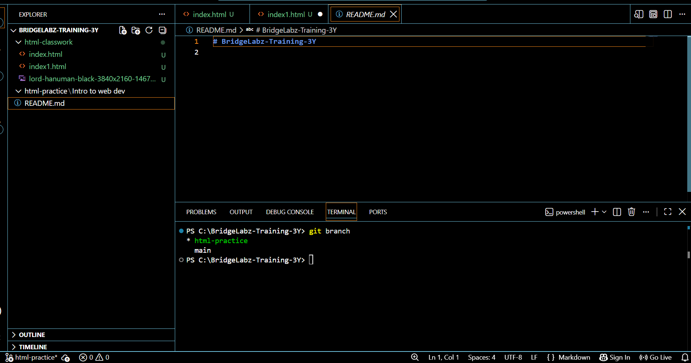

8. Difference Between Static and Dynamic Websites
Static Website Dynamic Website
Fixed content Content changes dynamically
HTML and CSS only Uses server-side languages and databases
Faster More interactive
No database Database connected
Examples
Static Website
• Personal portfolio
• Company information page
Dynamic Website
• Facebook
• Amazon
• Online banking websites

9. Five Web Browsers and Their Rendering Engines
Browser Rendering Engine
Google Chrome Blink
Mozilla Firefox Gecko
Microsoft Edge Blink
Apple Safari WebKit
Opera Blink

10. Basic Web Architecture Diagram
+------------------+
| Client |
| (Web Browser) |
+--------+---------+
|
HTTP Request
|
v
+------------------+
| Web Server |
+--------+---------+
|
+----------------+----------------+
| |
v v
+-------------------+ +------------------+
| Database | | APIs |
| (MySQL, MongoDB) | | Payment, Maps |
+---------+---------+ +---------+--------+
\ /
\ /
+---------+-----------+
|
Response/Data
|
v
+---------------+
| Client |
| Displays Page |
+---------------+

